Day: 15 (02-11-2026) | Snowflake – Load csv file content into Snowflake table | Documented By:
Task – 2 | Snowflake – Load csv file content into Snowflake table | Sujit T K

- Create a database (to hold data objects):
CREATE DATABASE IF NOT EXISTS AJI_FINANCE_DB;
SHOW DATABASES LIKE 'AJI_FINANCE_DB'; //to verify the creation of database
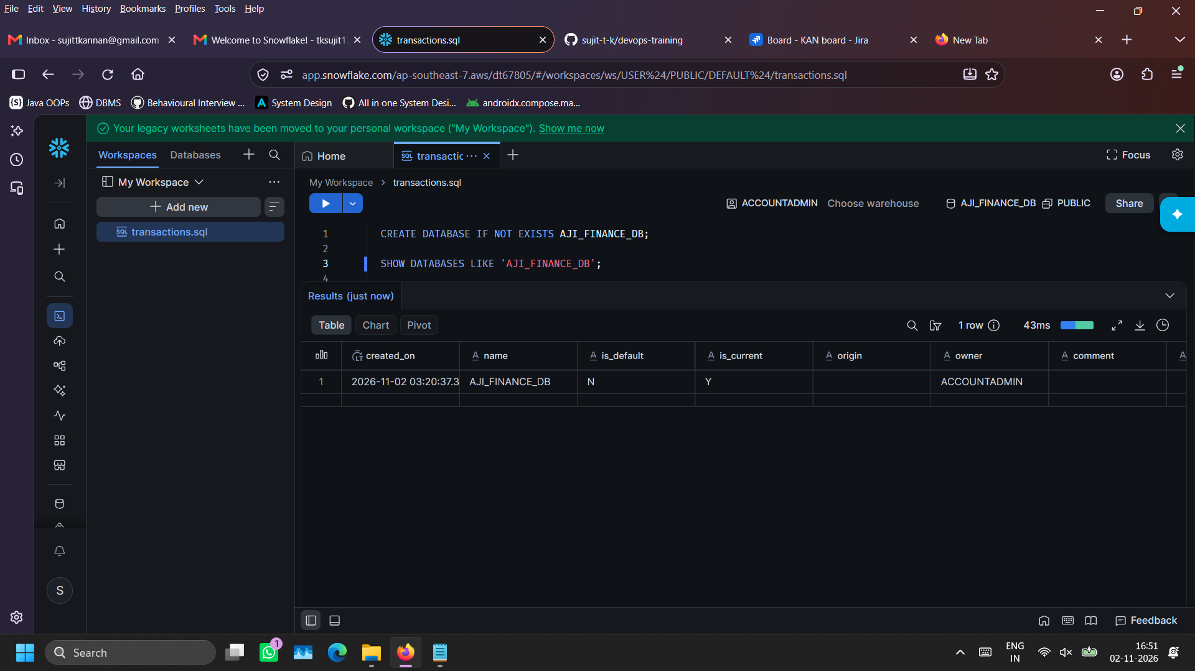
- Create schema (container within database that can hold tables):
CREATE SCHEMA IF NOT EXISTS AJI_FINANCE_DB.AJI_FINANCE_SCHEMA;
USE SCHEMA AJI_FINANCE_DB.AJI_FINANCE_SCHEMA; //to select current schema
SHOW SCHEMAS IN DATABASE AJI_FINANCE_DB; //to verify creation of schema
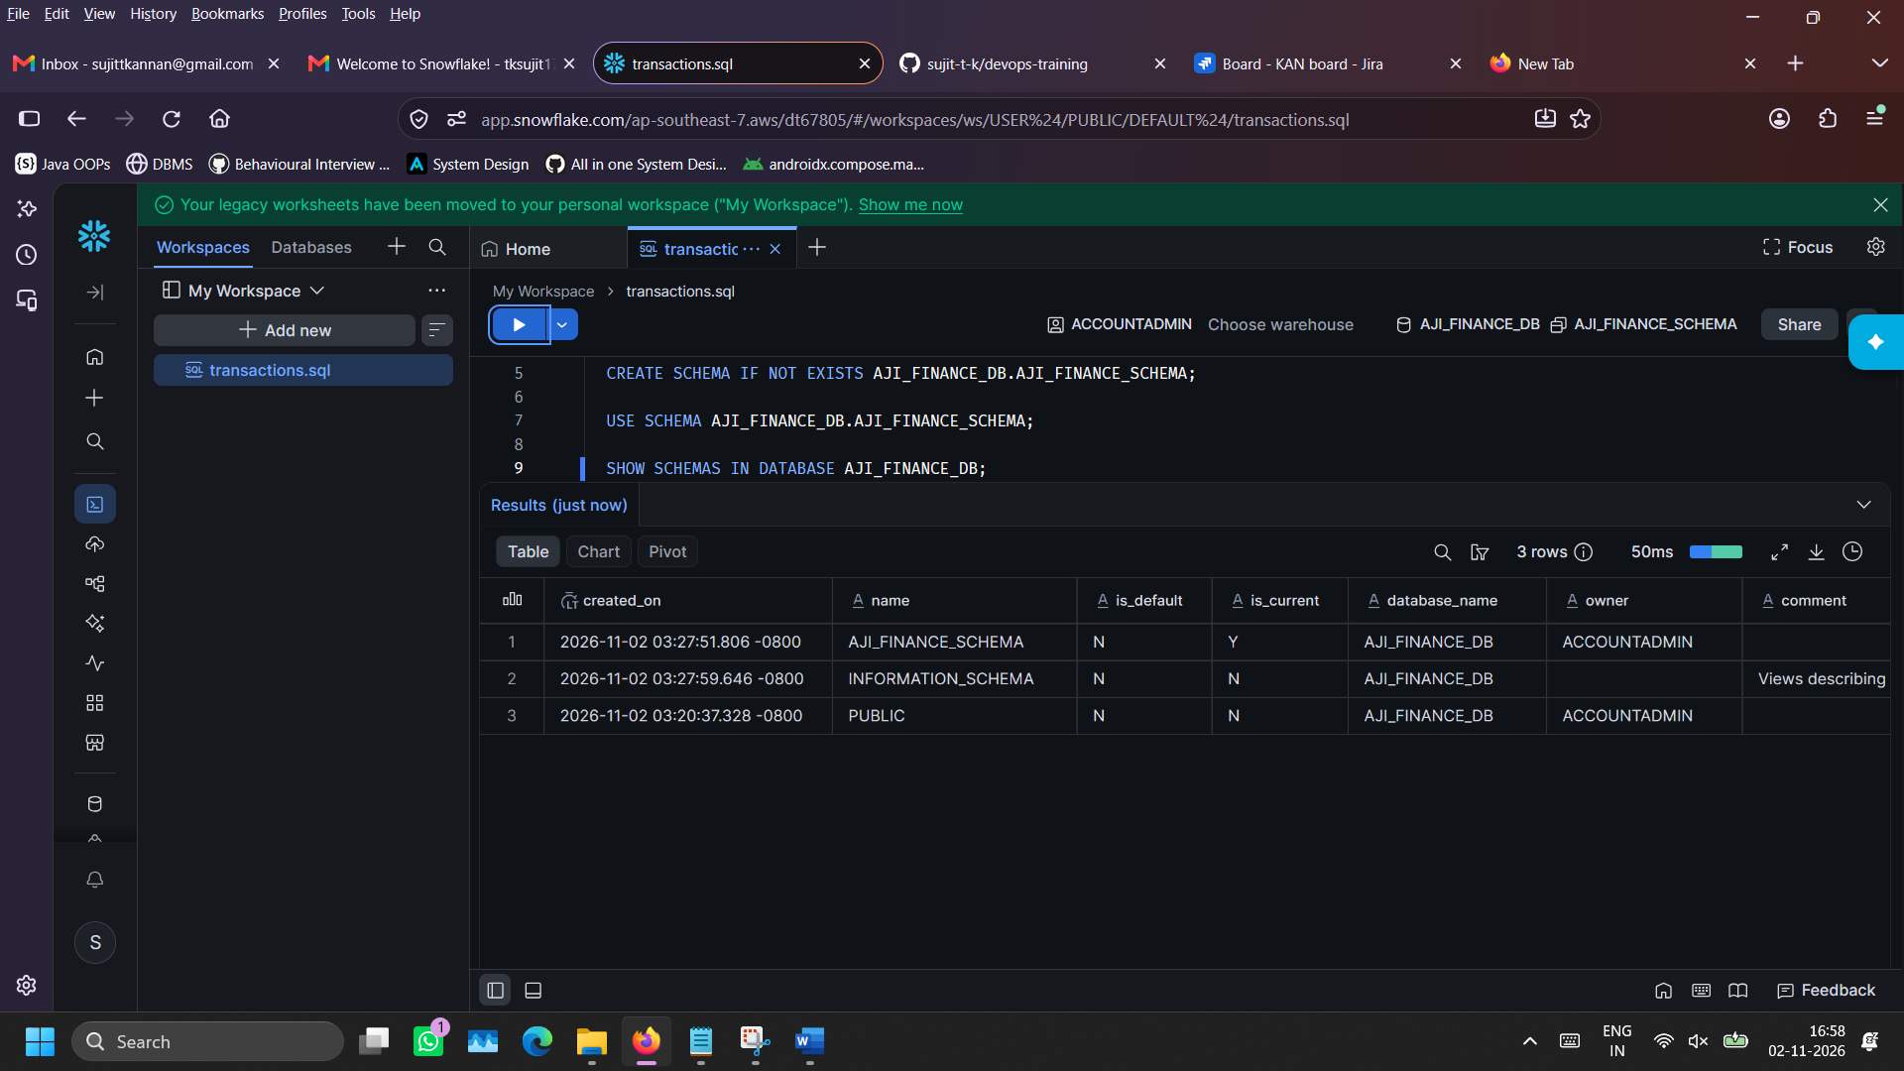
- Warehouse creation (to store data):
CREATE WAREHOUSE IF NOT EXISTS AJI_FINANCE_WH
WAREHOUSE_SIZE = 'SMALL'
AUTO_SUSPEND = 60
AUTO_RESUME = TRUE
INITIALLY_SUSPENDED = TRUE;

USE WAREHOUSE AJI_FINANCE_WH; //selects as current warehouse

SHOW WAREHOUSES LIKE 'AJI_FINANCE_WH'; //to verify creation of warehouse
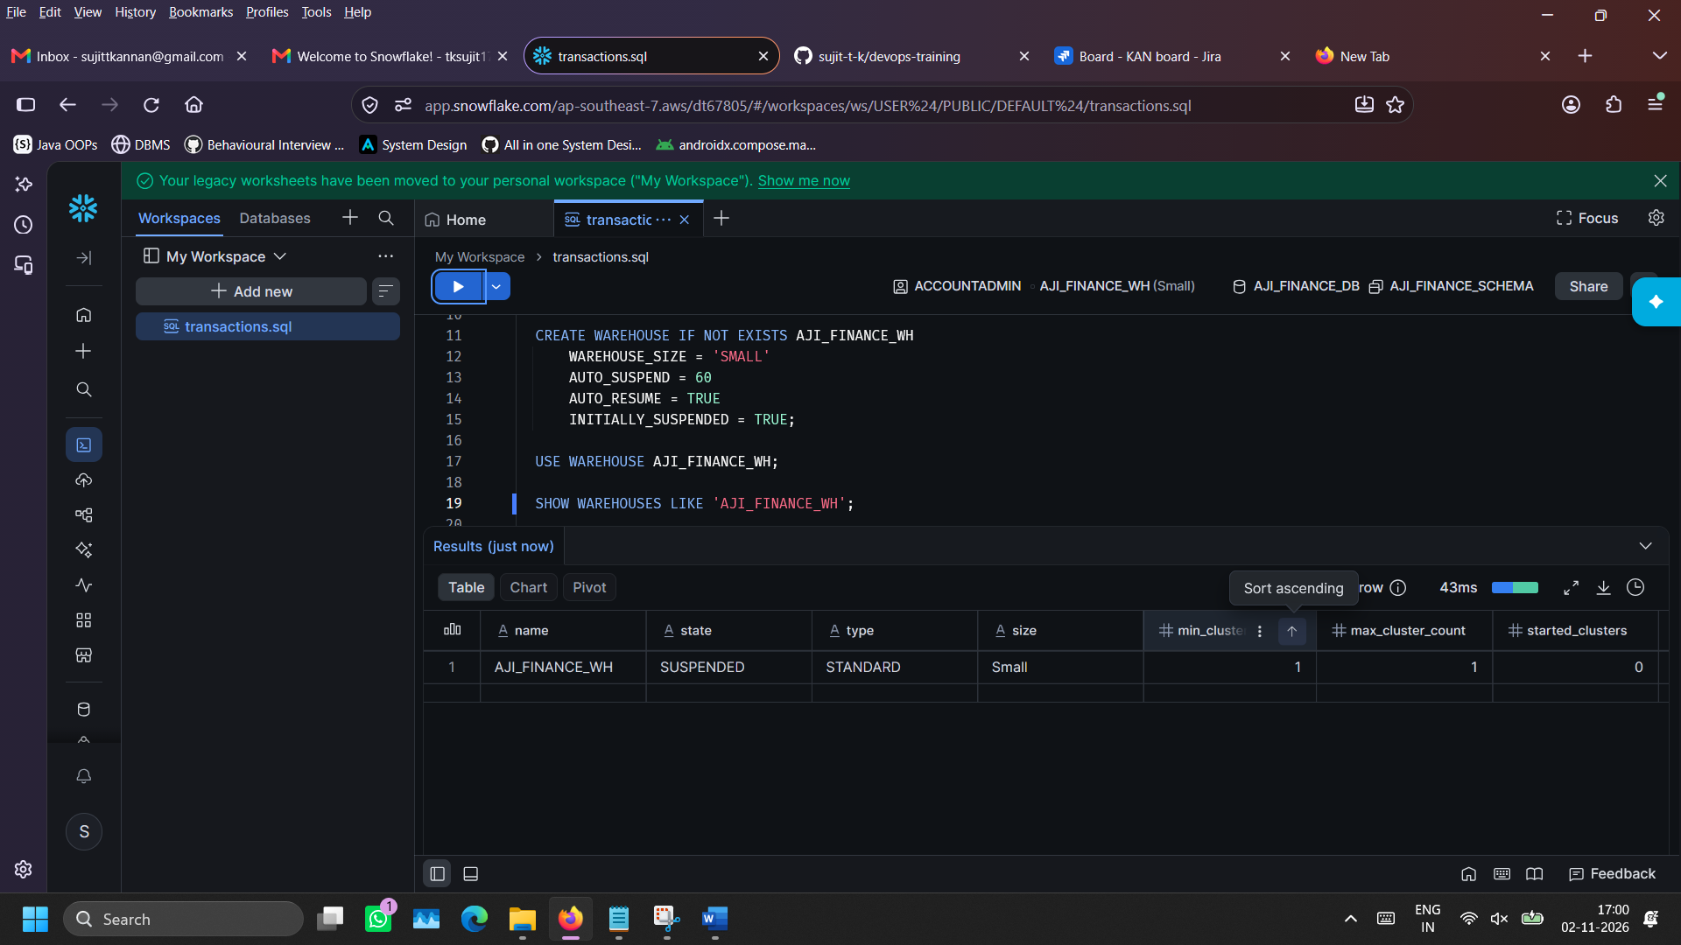
- Creating table in Snowflake: (to orgnaise and store records):
CREATE TABLE IF NOT EXISTS AJI_FINANCE_DB.AJI_FINANCE_SCHEMA.AJI_FINANCE_TRANSACTIONS (
TRANSACTION_ID VARCHAR(32),
TRANSACTION_TIMESTAMP TIMESTAMP_NTZ,
SENDER_ID VARCHAR(32),
RECEIVER_ID VARCHAR(32),
TRANSACTION_TYPE VARCHAR(32),
TRANSACTION_STATUS VARCHAR(32),
AMOUNT NUMBER(12,2),
FEE_AMOUNT NUMBER(10,2),
PAYMENT_CATEGORY VARCHAR(64),
DEVICE_TYPE VARCHAR(32),
BANK_PARTNER VARCHAR(64),
LOCATION_CITY VARCHAR(64)
);

SHOW TABLES LIKE 'AJI_FINANCE_TRANSACTIONS' IN SCHEMA AJI_FINANCE_DB.AJI_FINANCE_SCHEMA; //to verify creation of table
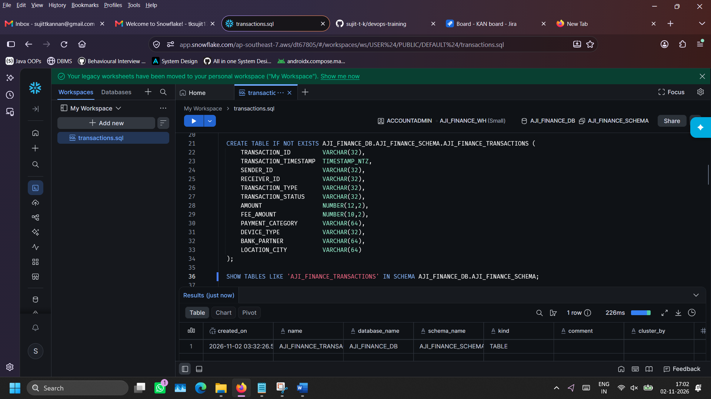
- Inspecting the table (to view the column names and datatype)
DESCRIBE TABLE AJI_FINANCE_DB.AJI_FINANCE_SCHEMA.AJI_FINANCE_TRANSACTIONS;
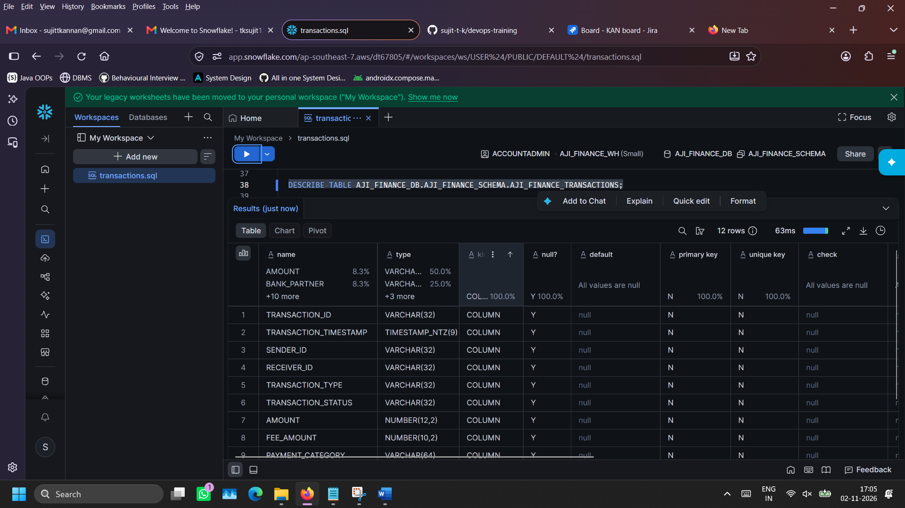
- File format creation: (Mention the file format that can be imported into the snowflake stage)
CREATE FILE FORMAT IF NOT EXISTS AJI_FINANCE_CSV_FORMAT
TYPE = CSV
SKIP_HEADER = 1
FIELD_OPTIONALLY_ENCLOSED_BY = '"'
EMPTY_FIELD_AS_NULL = TRUE
TIMESTAMP_FORMAT = 'YYYY-MM-DD HH24:MI:SS';

SHOW FILE FORMATS IN SCHEMA AJI_FINANCE_DB.AJI_FINANCE_SCHEMA; //to ensure the creation of the file format
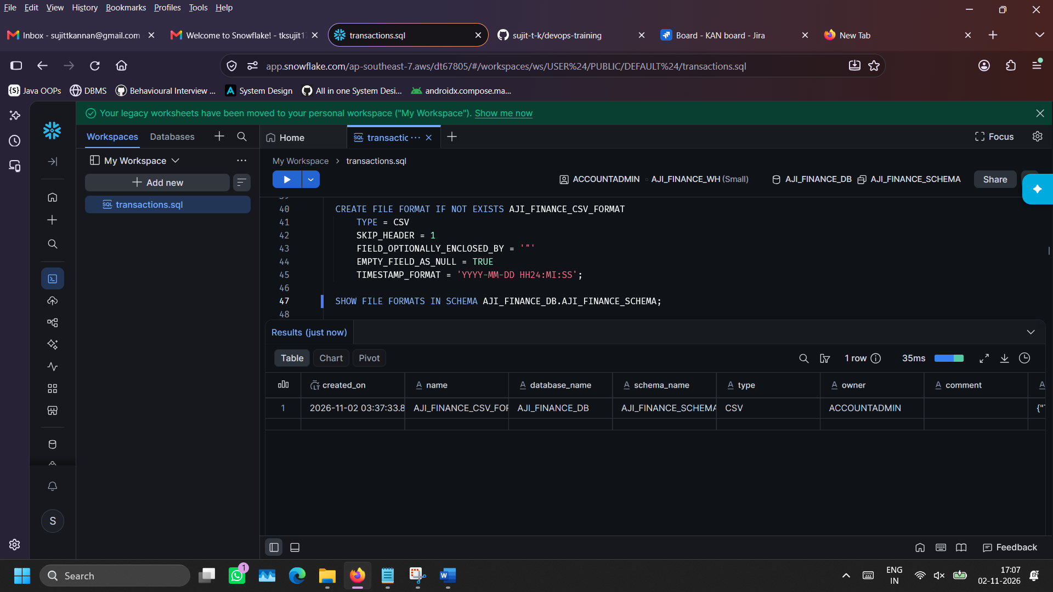
- Creating stage (a location where external file can be uploaded into snowflake environment):
CREATE STAGE IF NOT EXISTS AJI_FINANCE_STAGE
FILE_FORMAT = AJI_FINANCE_CSV_FORMAT;

SHOW STAGES IN SCHEMA AJI_FINANCE_DB.AJI_FINANCE_SCHEMA;//to verify the creation of the stage
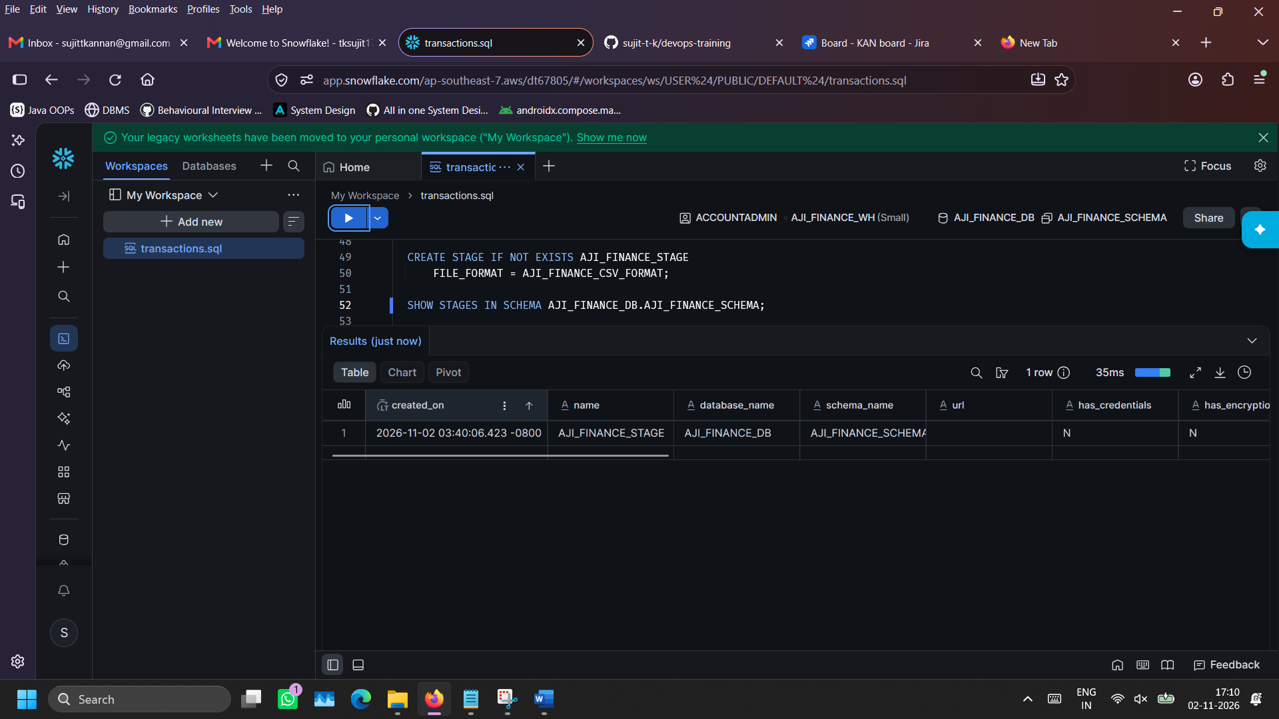
- Upload .csv file into AJI_FINANCE_STAGE (so that the .csv file can be accessed internally later):
On left side bar, go to Catalog -> Explorer -> Databases -> AJI_FINANCE_DB -> AJI_FINANCE_SCHEMA -> Stages. Click on AJI_FINANCE_STAGE. Then on top-right “Upload Files” button would be there. Click on it and locate the csv file. After successful upload, the csv file would be listed in the stage.
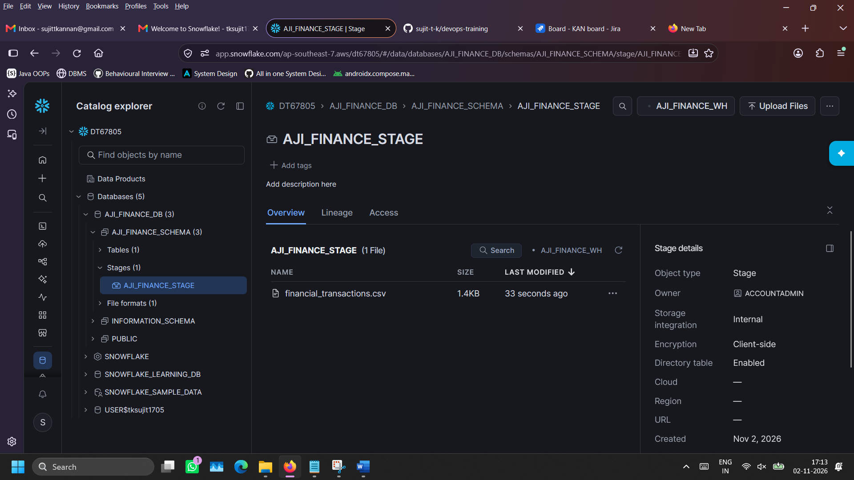
- Verification of file uploaded into the stage: (verify using SQL)
LIST @AJI_FINANCE_DB.AJI_FINANCE_SCHEMA.AJI_FINANCE_STAGE;
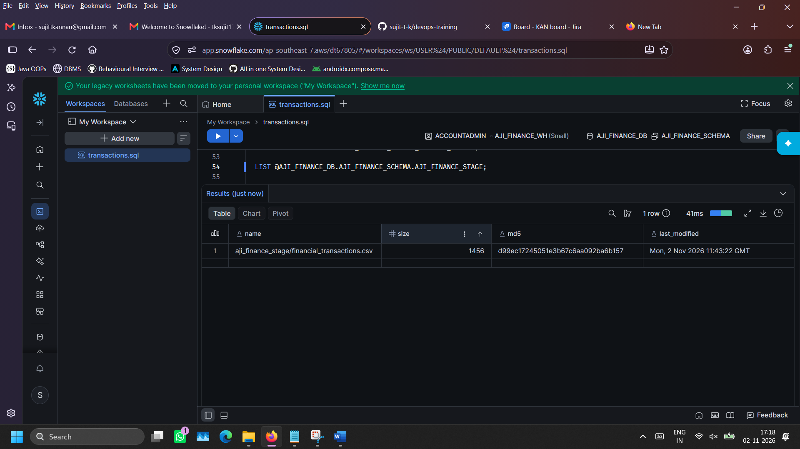

- Transfer content from stage’s csv file to AJI_FINANCE_TRANSACTIONS table:
COPY INTO AJI_FINANCE_DB.AJI_FINANCE_SCHEMA.AJI_FINANCE_TRANSACTIONS
FROM @AJI_FINANCE_DB.AJI_FINANCE_SCHEMA.AJI_FINANCE_STAGE
FILE_FORMAT = (FORMAT_NAME = 'AJI_FINANCE_DB.AJI_FINANCE_SCHEMA.AJI_FINANCE_CSV_FORMAT')
ON_ERROR = 'ABORT_STATEMENT';
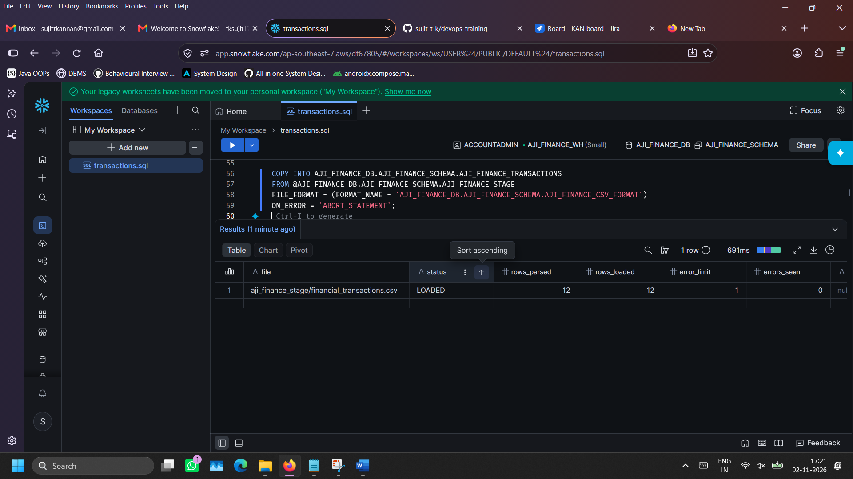
- Execute SQL queries on the table:
11.1) Project all records of the table (to verify whether all data has been loaded successfully)
SELECT COUNT(*) AS TOTAL_TRANSACTIONS
FROM AJI_FINANCE_DB.AJI_FINANCE_SCHEMA.AJI_FINANCE_TRANSACTIONS;
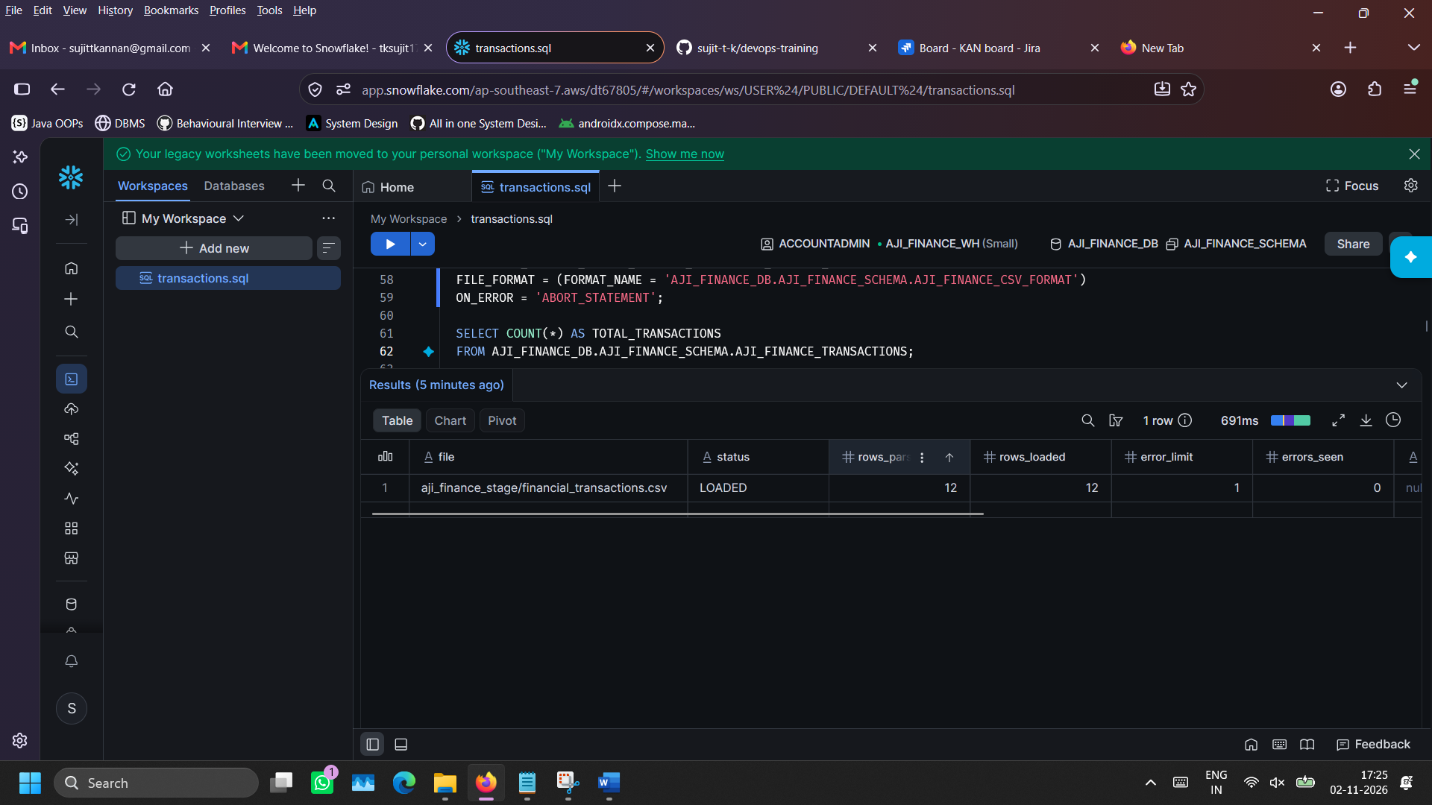

11.2) Grouping & Aggregation - Retrieve transactions count, total amount and average amount of each transaction type

SELECT
TRANSACTION_TYPE,
COUNT(*) AS TXN_COUNT,
SUM(AMOUNT) AS TOTAL_AMOUNT,
ROUND(AVG(AMOUNT), 2) AS AVG_AMOUNT
FROM AJI_FINANCE_TRANSACTIONS
GROUP BY TRANSACTION_TYPE
ORDER BY TOTAL_AMOUNT DESC;

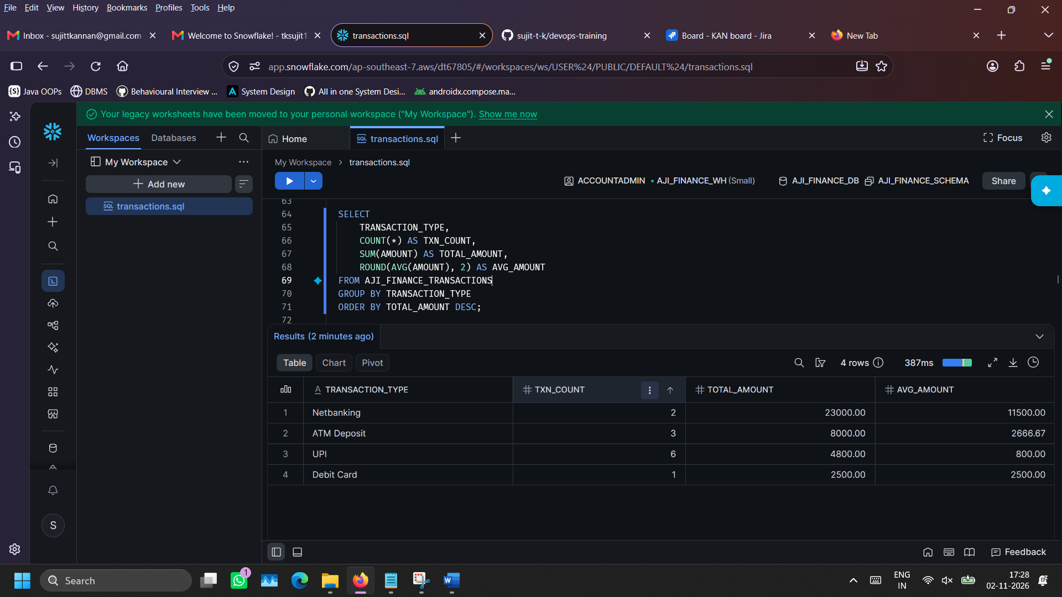

11.3) Grouping, Aggregation & Sorting - Information of number of transactions initiated, failed and succeeded in each city

SELECT
LOCATION_CITY,
TRANSACTION_STATUS,
COUNT(*) AS STATUS_COUNT,
SUM(AMOUNT) AS TOTAL_VOLUME
FROM AJI_FINANCE_TRANSACTIONS
GROUP BY LOCATION_CITY, TRANSACTION_STATUS
ORDER BY LOCATION_CITY, STATUS_COUNT DESC;
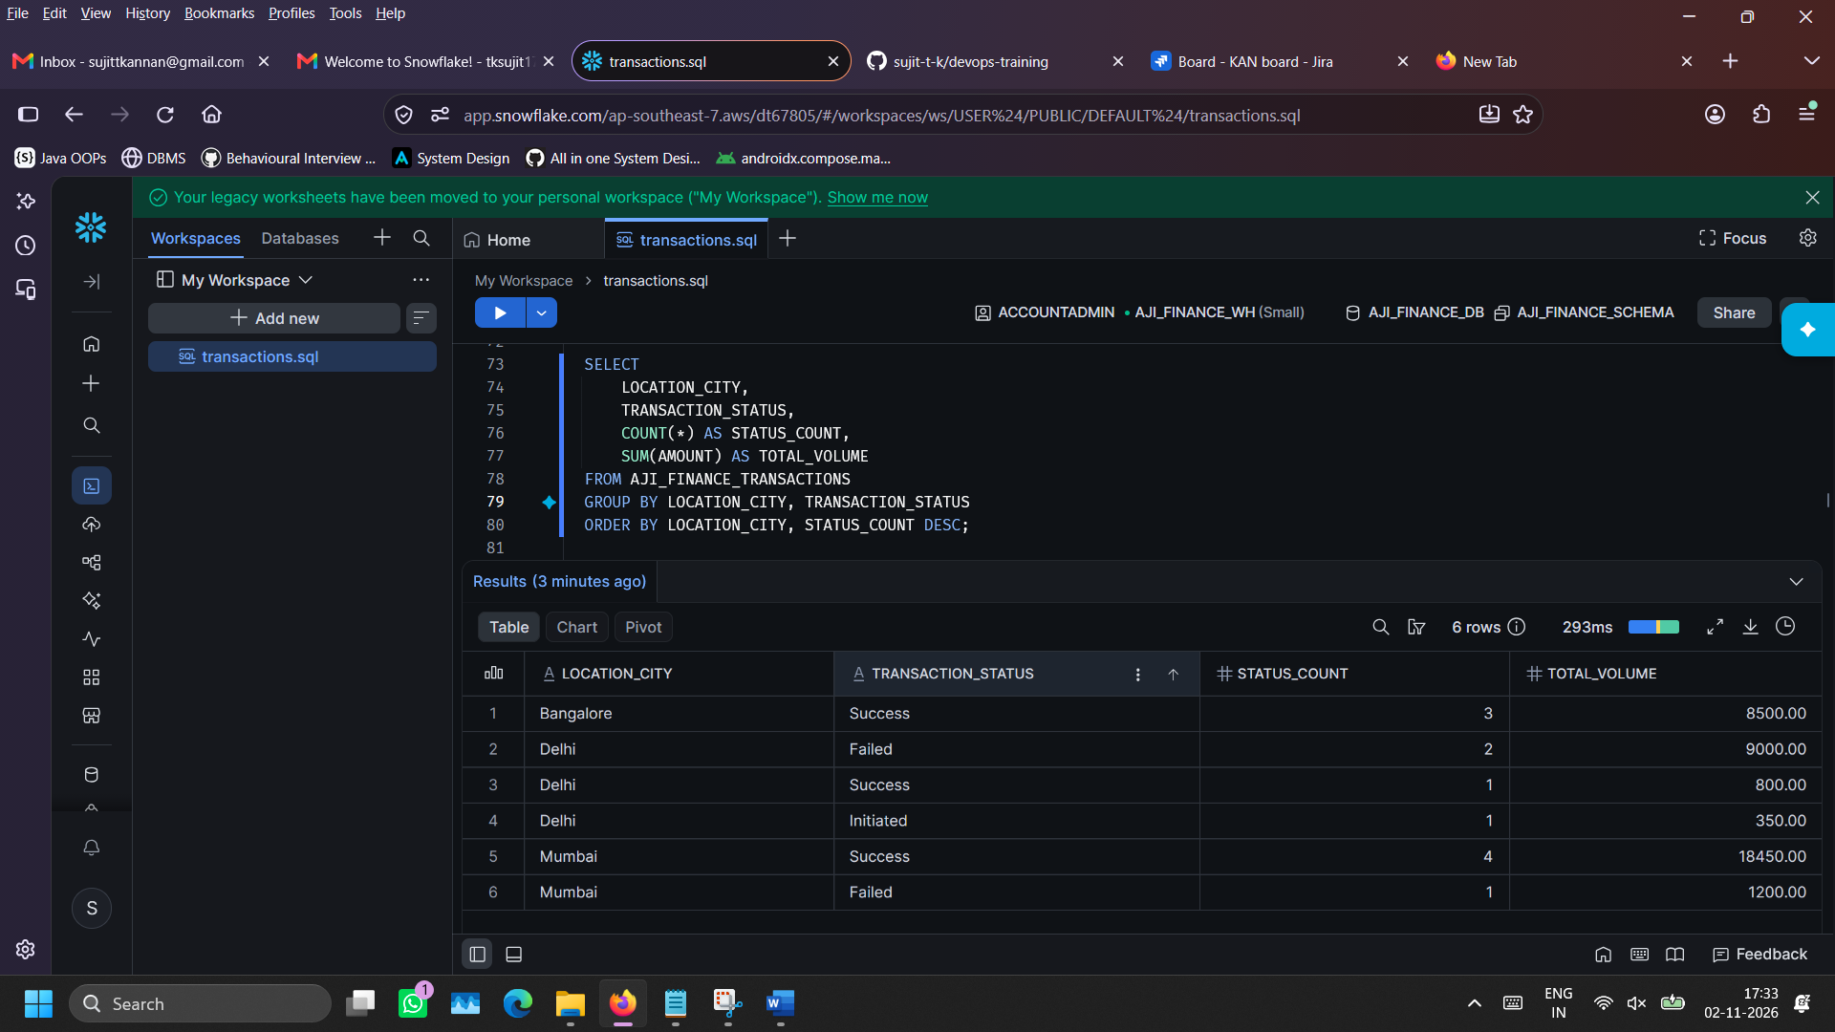

11.4) Subquery execution – Identifying successful transaction which involves more than average transaction amount
SELECT *
FROM AJI_FINANCE_TRANSACTIONS
WHERE TRANSACTION_STATUS = 'Success'
AND AMOUNT > (
SELECT AVG(AMOUNT)
FROM AJI_FINANCE_TRANSACTIONS
WHERE TRANSACTION_STATUS = 'Success'
)
ORDER BY AMOUNT DESC;

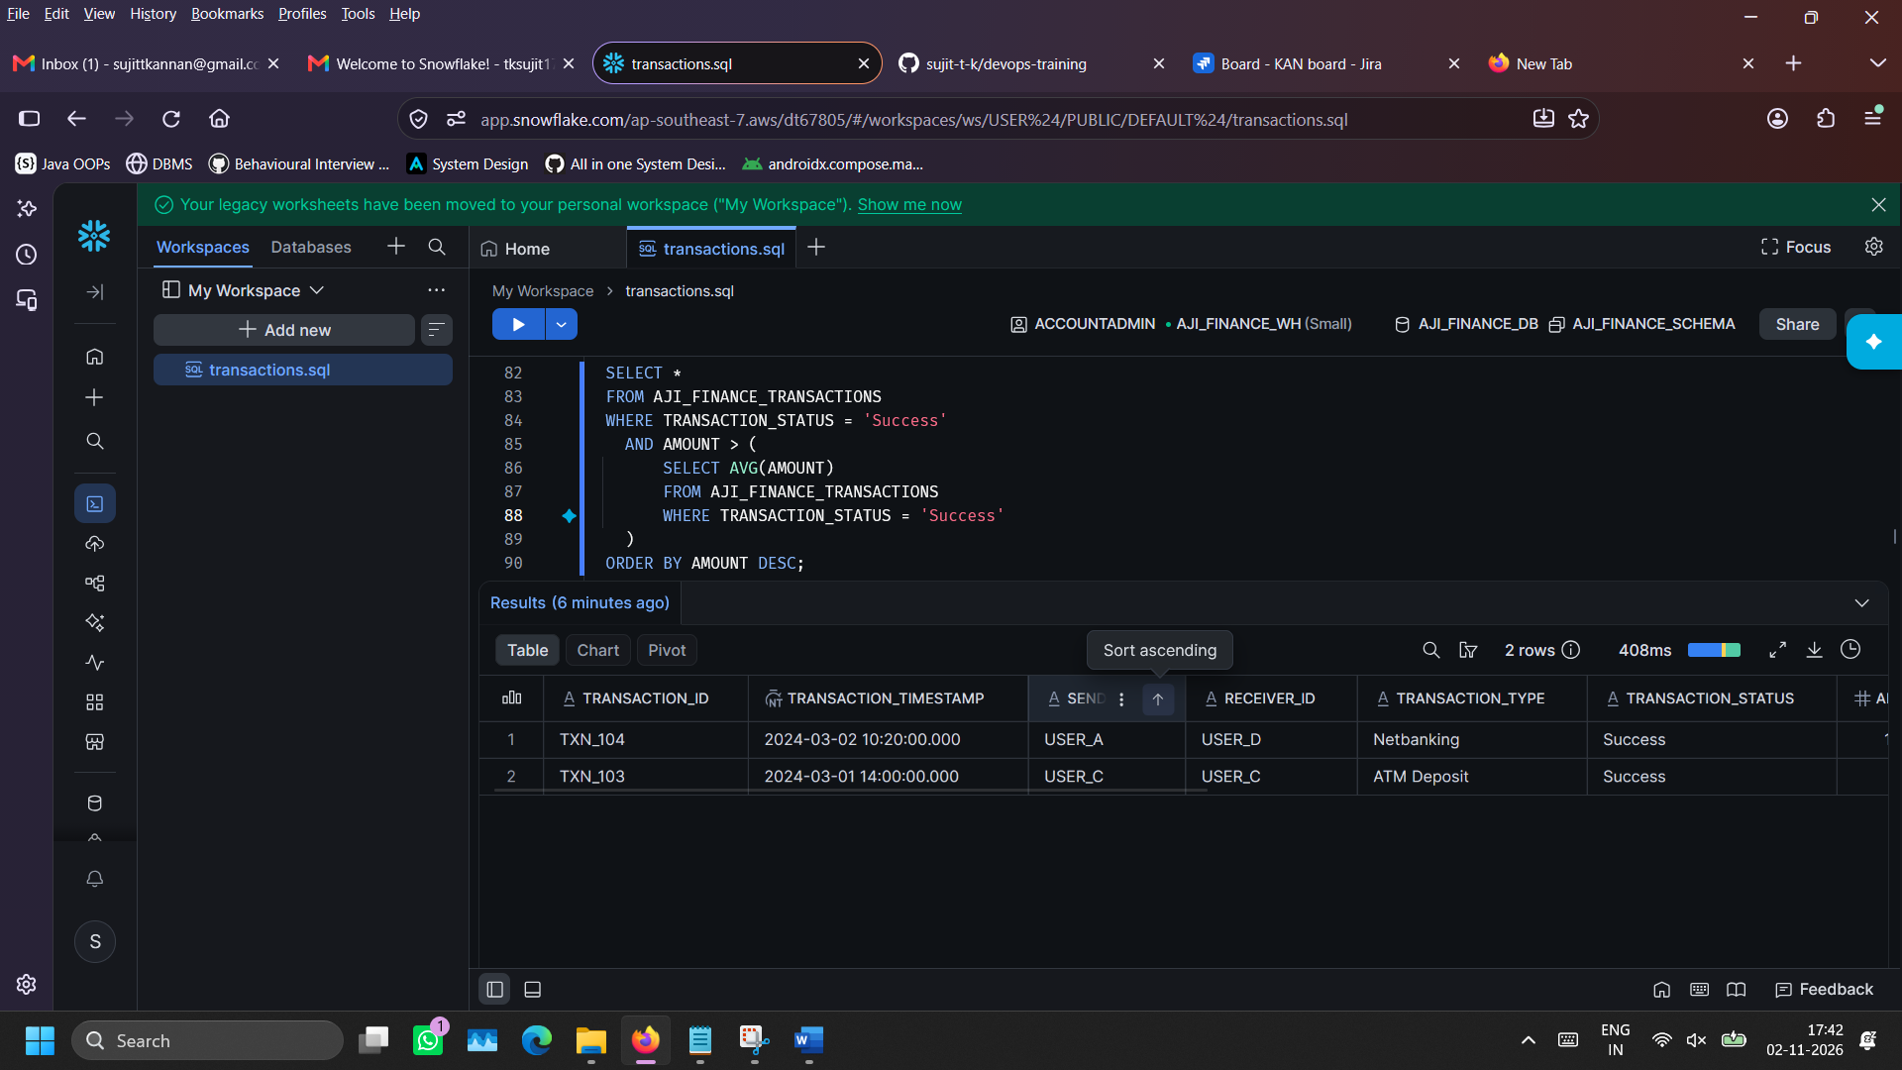
- Deletion of database, warehouse and .sql file from workspace (so that additional costs doesn’t incur):

DROP DATABASE IF EXISTS AJI_FINANCE_DB;
DROP WAREHOUSE IF EXISTS AJI_FINANCE_WH;



